**FINAL PORTFOLIO**

TEAM 4

**CleckShopHub**

**Team Members:**

**Abhisek Poudel**

**Amulya Shrestha 77356835**

**Biliyas Maharjan**

**Biraj Shrestha**

**Shashank Shrestha**

**Soya Shrestha**

**Susan Bhandari**

**TABLE OF CONTENS**

5. Frequently Asked Questions pg190

5.Frequently Asked Questions

i. What is cleckhuddersfaxfoodhub.com?

Cleckhuddersfaxfoodhub.com is a collaborative venture of a group of local grocery stores from Cleckhuddersfax with a motive to provide a

hassle free online grocery store.

i. Why use our service?

In today’s hustle and bustle, people are busy with their life. We aim to make grocery shopping convenient and quick with options for online as well as cash transactions

ii. Can I return an item?

As we sell fresh products that are subjected to quick decay, we do not accept returns.

iii. Why use our service?

As we sell fresh products that are subjected to quick decay, we do not accept returns. However, if you're not satisfied with the product, you can always post a review!

# Project Planning

## d. Skill Audit

### I. Team Skills Audit

### 

### II. Individual Skills Audit



Figure : Abhishek Poudel Individual Skill Audit



Figure : Amulya Shrestha Individual Skill Audit

## e. Project Management

### I. Gantt Chart

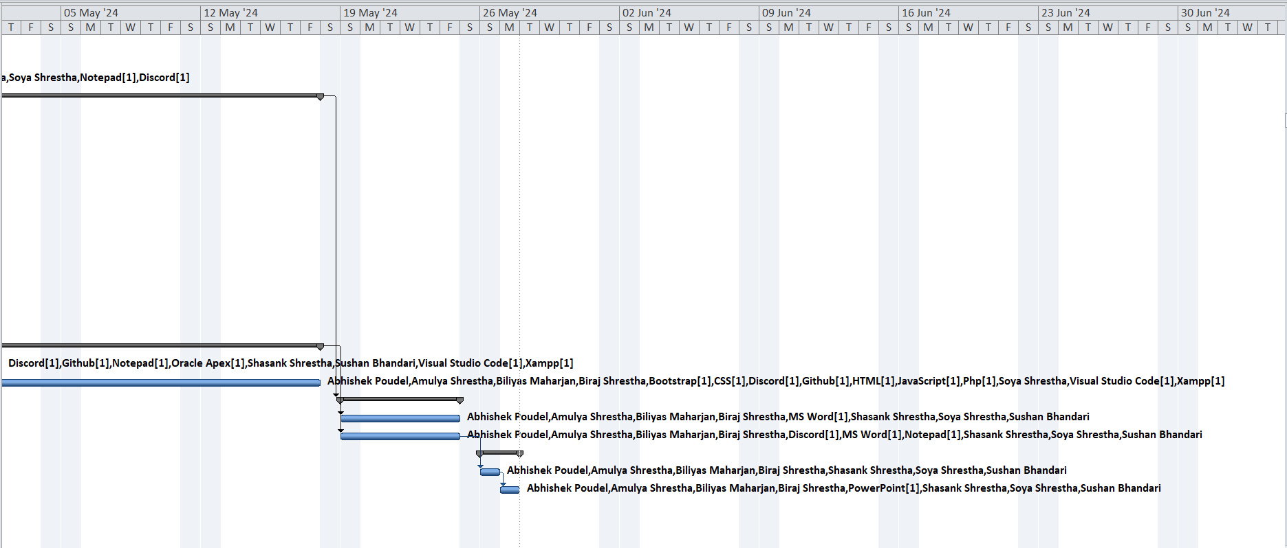

### II. Task Sheet

### III. Timeline

### IV. Resource Sheet

### V. Calendar

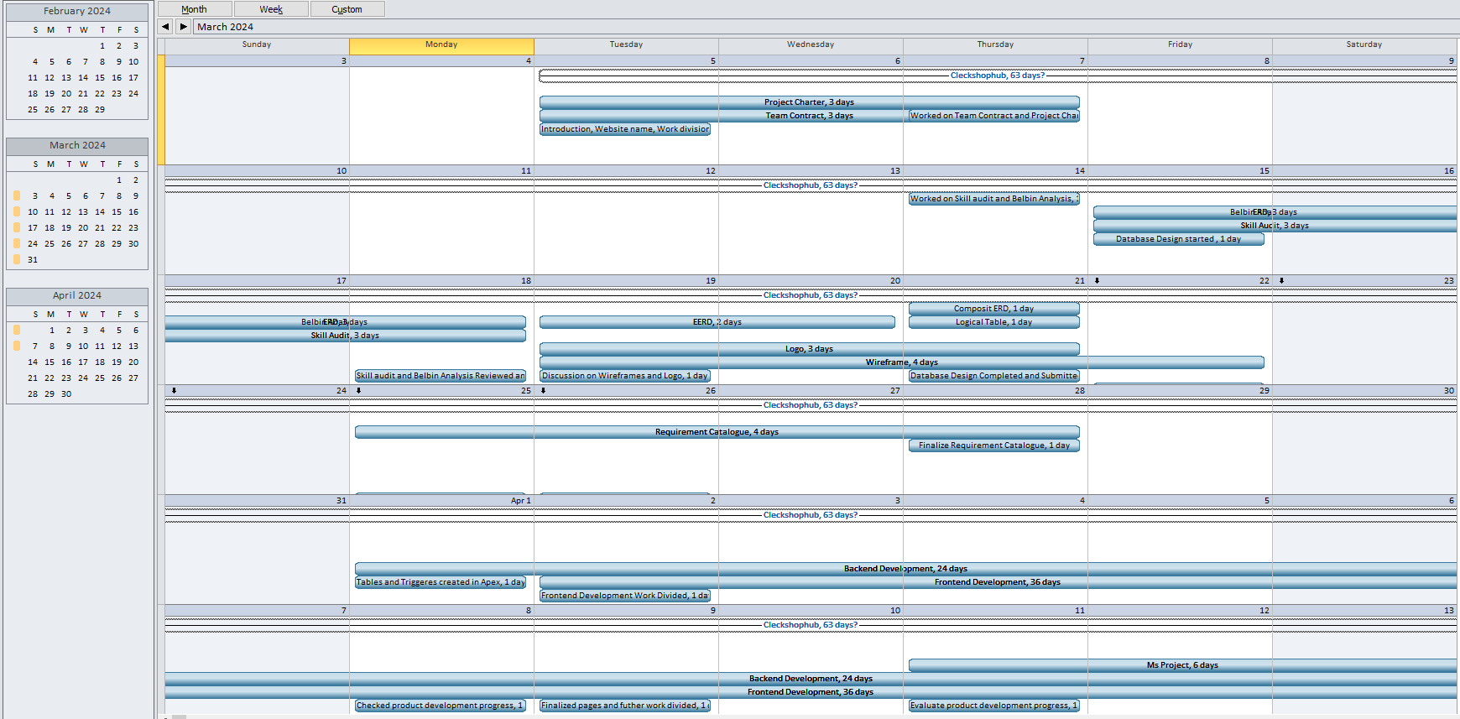

### VII. Change in Working Time

## f. Communication and collaboration tools

### I. Discord

### II. Github

## g. Team Meetings

**Virtual Meeting:**

**Day 1(03/05/24): (Online)**

**Objectives:**

* Introduction of the team members
* Division of work among the team members.
* Website name decided (i.e. CleckShopHub).

**Day 2 (03/07/24): (Online)**

**Objectives:**

* Began with the contract work and project charter.
* Deliberation and agreement on the project contract.

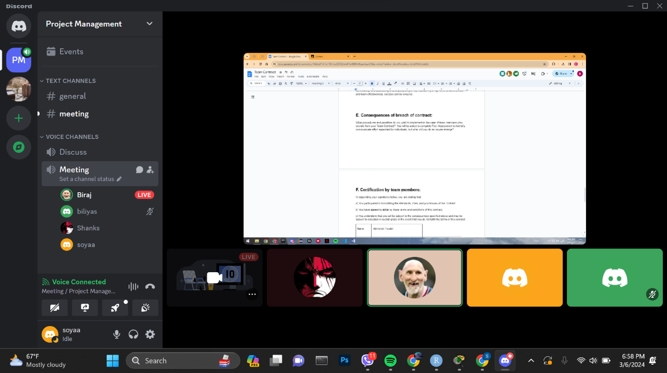

**Day 3 (03/14/24): (Online)**

**Objectives:**

* Reflected upon individual strengths and weaknesses for Skill audit.
* Decided and discussed suitable Belbin roles for each member.

**Day 4(03/15/24): (Online)**

**Objectives:**

* Prepared ERD diagram to design database models used in our site.

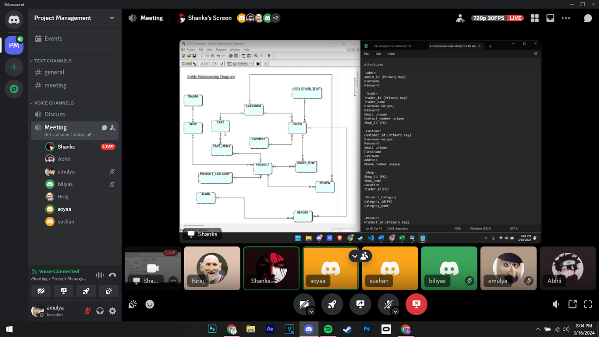

**Day 5(03/18/24): (Physical)**

**Objectives:**

* Began creating wireframes for web pages using Figma.
* Continued working on the ERD.
* Discussion on the logo.
* Started designing a website logo
* Commenced work on the wireframe.

**Day 6(03/19/24): (Physical)**

**Objectives:**

* Made various versions of logo

**Day 7(03/21/24): (Online)**

**Objectives:**

* EERD/ERD/Final Composite & Decomposition ERD/ Logical Table discussion and submission.
* Continued making wireframes.

**Day 8(03/22/24):**

**Objectives:**

* Started working on Use Case Diagram
* Continued Wireframe.
* Started working on use case diagram
* Discussion on Functional and Non-Functional Requirements.

**Day 9(03/25/24):**

**Objectives:**

* Worked on Functional and non-functional requirements

**Day 10(03/26/24): (Online)**

**Objectives:**

* Finalizing Use Case Diagram
* Discussion on Functional and Non-Functional Requirements.

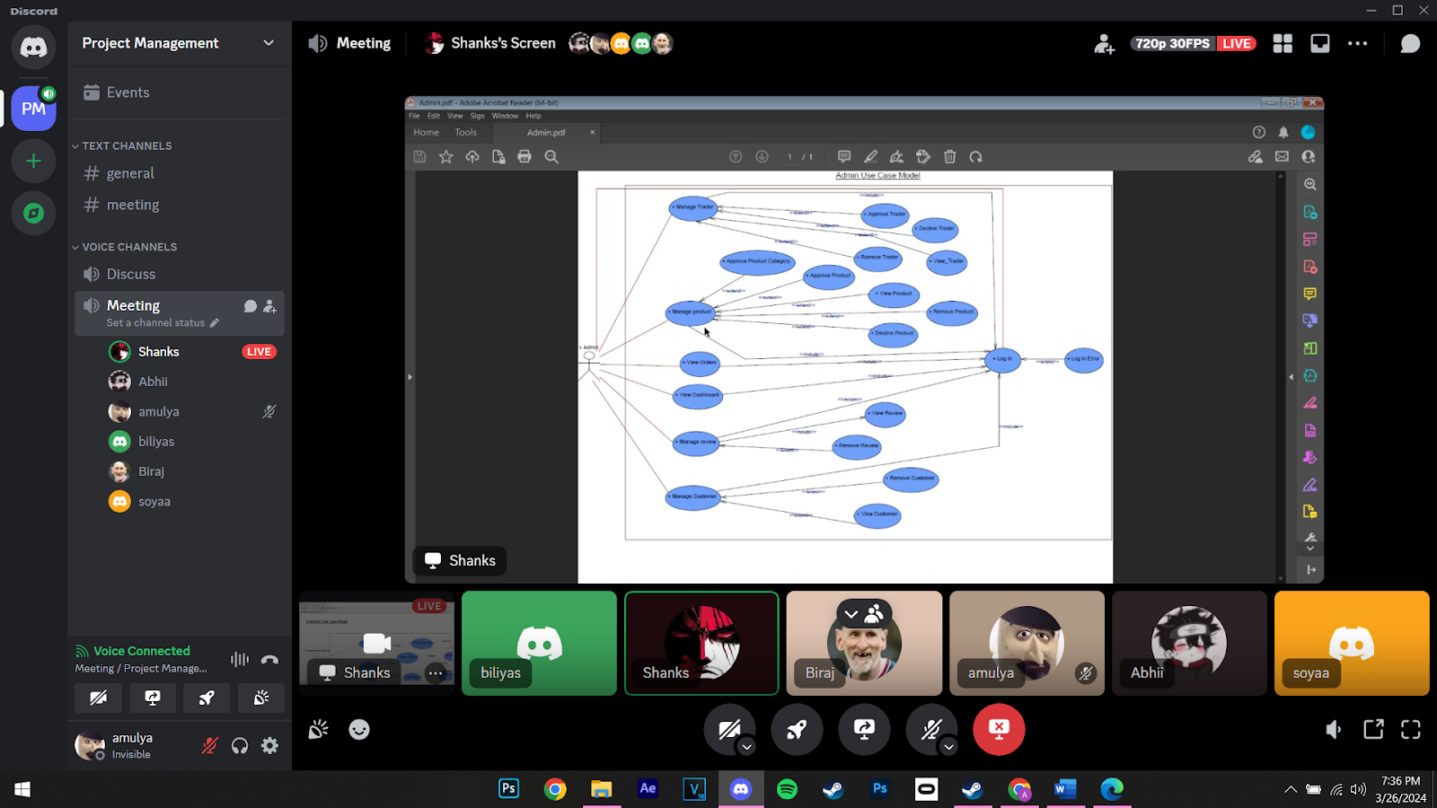

**Day 11(03/28/24): (Online)**

**Objectives:**

* Submission of Use case diagram and functional and non-functional requirements.

**Day 12(04/01/24): (Online)**

**Objectives:**

* Submission of Use case diagram and functional and non-functional requirements.
* Commenced making tables and triggers in Apex

**Day 13(04/02/24): (Physical)**

**Objectives:**

* Discussion on how to further proceed on the project
* Division on individual work (HTML, CSS)
* Table created in the database

**Day 14(04/08/24): (Physical)**

**Objectives:**

* Checked on individual progress.
* Discussion on what changes should be made in HTML and CSS
* Triggers were created in the database

**Day 15(04/09/24): (Physical)**

**Objectives:**

* Finalized the HTML and CSS work and decided how to combine individual works.
* Individual work was pushed, creating each folder in the GIT hub

**Day 16(04/11/24): (Physical)**

**Objectives:**

* Discussion on work progress and how to further proceed with the project

**Day 17(04/15/24): (Online)**

**Objectives:**

* Started maintaining schedules on MS Project

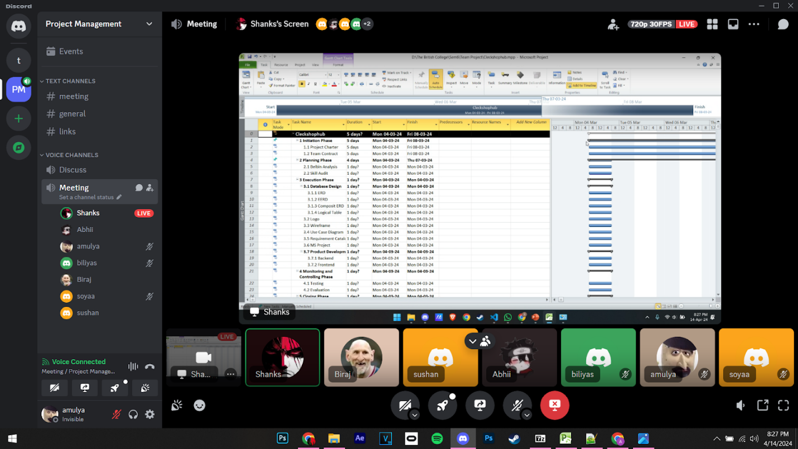

**Day 18(04/18/24): (Online)**

**Objectives:**

* Finalized ms project
* Made necessary changes in slides and word file for wip

**Day 19(04/19/24): (Physical)**

**Objectives:**

* Finalized ms project
* Made necessary changes in slides and word file for wip

# 2. Product Designing